CSA05-DATABASE MANAGEMENT SYSTEMS
LAB OBSERVATION
EXPERIMENT:05
AIM:
To view the records from the tables using SELECT commands with WHERE Clause and Pattern matching.
QUESTION:
1. The student counselor wanted to display the registration number, student name and date of birth for all the students.
SQL QUERIES:
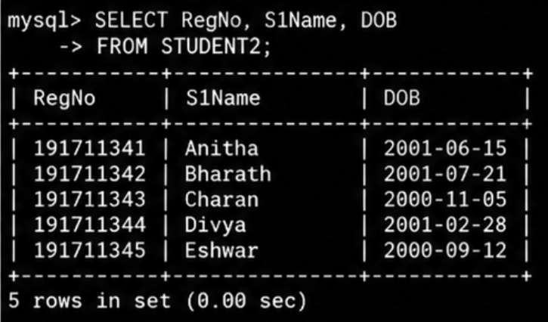
2. The controller of examinations wanted to list all the female students
SQL QUERIES:
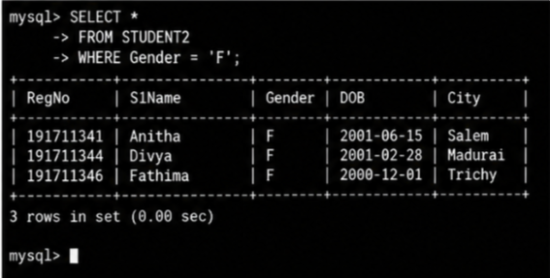
3. List the Students who registered for the “C001” course.
SQL QUERIES:
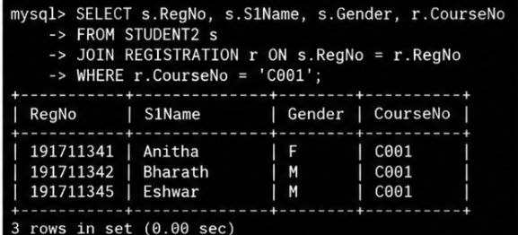
4. Display all faculty details joined before “November 2014”
SQL QUERIES:
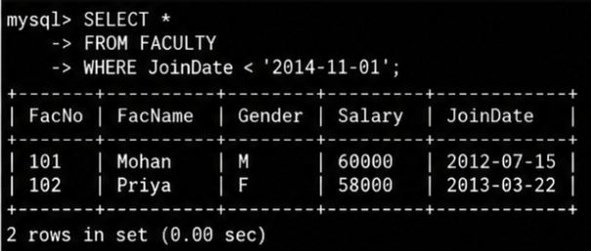
5. Display all the courses not allotted to hall ‘H001’
SQL QUERIES:
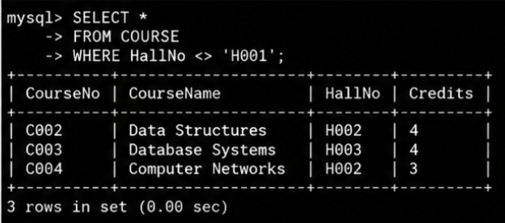
6. List the students whose name ends with the substring “sh”
SQL QUERIES:
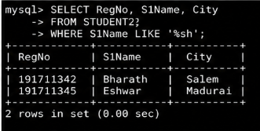
7. Display all students whose name contains the substring “sh”
SQL QUERIES:
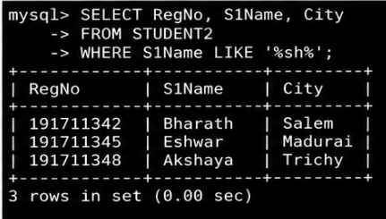
8. Find all the students who are located in cities having “Sal” as substring
SQL QUERIES:
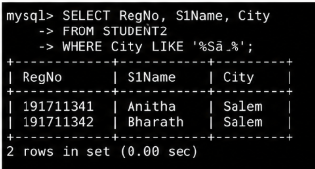

9. Display the students whose names do not contain six letters.
SQL QUERIES:
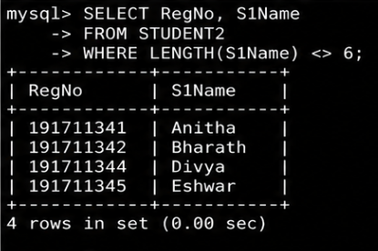
10. Find all the students whose names contains “am”.
SQL QUERIES:
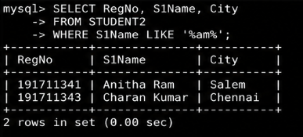

RESULT:
The records from the tables are displayed using SELECT commands with WHERE Clause and Pattern matching.

